DC/4(a)/Jul/2022

**EXPERIMENT No.:4(A)**

**TITLE**: **Study of Line coders: UPNRZ, PRZ, PNRZ, and BPRZ.**

**OBJECT:**

**a)** To study the nature of waveform of UPNRZ coding and see its spectrum by spectrum analyzer**.**

b) To study the nature of waveform of PNRZ coding and see its spectrum by spectrum

Analyzer**.**

**c)** To study the nature of waveform of PRZ coding and see its spectrum by spectrum analyzer**.**

**d)** To study the nature of waveform of BPRZ (AMI) coding and see its spectrum by spectrum analyzer**.**

**EQUIPMENTS REQUIRED:**

S. No. APPARATUS NAME Qnty.

1. Oscilloscope 01

2. Spectrum Analyzer 01

3. Experimental Kit

ST2106 01

4. Binary Data Generator 01

**THEORY:**

The source encoder converts an analog signal in to a stream of digital data. If the data is binary, it is a stream of ‘1’ and ‘0’. Logic ‘1’ and logic ‘0’ are represented by two waveforms. The simplest is to represent ‘1’ by a square pulse and ‘0’ by 0 volt. But the simplest is not always good enough as,

* This code has an average DC voltage, which will be lost through AC couplings.
* Also, a long sequence of ‘0’ may appear as a loss of transmission.

In order to take care of these and many other requirements, the symbols are transformed into various different wave shapes, a process named line coding is used for it. Different wave shapes result in different spectrum, suiting different needs. Hence in a way, line codes are also **spectrum shaping codes.**

**Necessary properties of line code:**

1. Self synchronization – It should be possible to recover the clock pulse from the received data. Clock should not be lost even in case of a long sequence of ‘0’.

2. Low probability of bit error – It should be convenient to design a receiver, which receives the specific line code and results a low probability of bit error.

3. PSD – Spectrum of the line code should suit the physical medium.

4. Band width – Band width of the line coded signal should be low.

5. No DC – DC power content should be ideally zero to enable AC coupling.

6. Low frequency power – Power at very low frequency should as low as possible.

7. To suit channel coding – Line code should be such that subsequent coding for error detection/correction is easy.

8. Power efficiency – Required transmission power should be small.

9. Transparency – Line code should be such that any sequence of ‘1’ & ‘0’ must have only one inference.

**Comparative study of line codes:**

**DIAGRAMS – UPNRZ, PNRZ, UPRZ, PRZ, AMI – RZ, Manchester**

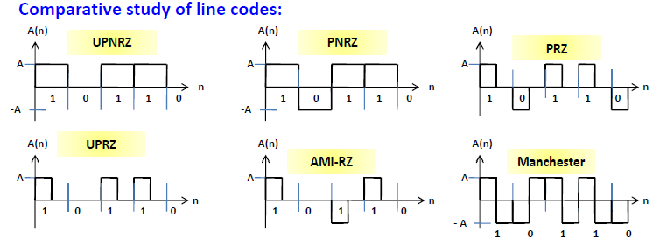

* UPNRZ and UPRZ are unipolar codes and need only single sided power supply to generate them whereas PNRZ, PRZ, AMI and Manchester need double sided power supply.
* AMI receiver needs to detect 3 levels. All other codes need to detect only2 levels.
* PNRZ, PRZ and Manchester carry a pulse in every bit. Hence, loss of pulse will warn about a failure. Whereas UPNR, UPNRZ, UPRZ and AMI do not have this benefit. long sequence of ‘0’ may be mistaken as failure of transmission.
* AMI has a built in error detecting capability since any ‘0’ being converted to ‘1’ or vice- versa will violate the code.

**Spectrums:**

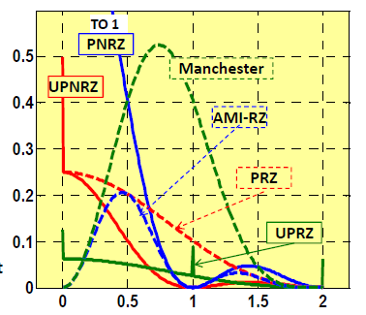

* First null BW for UPNRZ, PNRZ and AMI is Rb. Whereas for UPRZ, PRZ and Manchester, it is 2Rb, i.e. double.
* PNRZ has maximum DC power content.
* UPNRZ and PRZ also have high DC power content.
* UPNRZ has an additional power spike at DC.
* Hence UPNRZ, PNRZ and PRZ are not at all suitable for AC coupling.
* DC power of UPRZ is much smaller than in UPNRZ, PNRZ and PRZ. But due to its DC power spike, not advised for AC coupling.
* Both AMI and Manchester are suitable for AC coupling.
* UPRZ has a distinct power spike at Rb. Hence suitable to extract the synchronizing clock signal.
* PRZ, AMI and Manchester do not have power spike at Rb.
* But if rectified, these codes resemble UPRZ and hence the synchronizing signal can be extracted.

**EXPERIMENTAL PROCEDURE:**

1. Connect **DATA** and **CLOCK** from **BINARY DATA GENERATOR** to **DATA I/P** and **CLOCK I/P** OF **ST 2106** trainer respectively.

2. Examine the **UPNRZ (L)** at **t.p5** in **DATA FORMAT BLOCK** of **ST2106** trainer. Observe the spectrum of the signal by spectrum analyzer. Or **DSO** by using **FFT function**

* **Setting of spectrum analyzer:** i) Set SPAN to 100 kHz/Div, RBW 30 KHz in spectrum analyzer.

ii) Press center freq button & select center frequency.

iii) Press marker button to ‘**ON**’ the markers and put the markers in right position to measure the bandwidth &power.

* **Setting of DSO**: i) press **MATH/ FFT** button,

ii) From FFT menu select window function and source

iii) Press cursor button and in cursor menu (F1 button) choose source of the cursor (FFT).

iv) Use horizontal & vertical cursor to measure the band width & power.

3. Now connect **t.p5 to t.p20**. Observe the waveform **PNRZ (L)** from **t.p21.** Observe the spectrum of the signal by spectrum analyzer.

4. Connect **t.p7** to **t.p20**. and data clock to **t.p19.** Observe the **PRZ** o/p from **t.p21.** Observe the spectrum of the signal by spectrum analyzer.

5. Connect **t.p6 (NRZ (M)) to t.p20**. and **t.p7** to **t.p19**. Observe the **BPRZ** o/p from **t.p21.** Observe the spectrum of the signal by spectrum analyzer Or **DSO** by using **FFT function**

**Settings of spectrum analyzers and DSO are same as above for all.**

**EXPERIMENTAL SETUP:**

**1. UPNRZ: 2. PNRZ**

CLK from Binary data generator

Unipolar to Bipolar Converter

ST 2106

Data formatting circuit

t.p 5 t.p 21

DATA from o/p from t.p 5 to o/p

Binary data t.p 20

generator

**3. PRZ**

CLK from Binary data generator

t.p19

**Unipolar to Bipolar Converter**

**ST 2106**

from t.p7(RZ) to t.p20 t.p21 o/p

#### Fig3

**4. BPRZ**

From t.p7( RZ o/p) to

t.p19

**Unipolar to Bipolar Converter**

**ST 2106**

from t.p 6(NRZ(M)) t.p21 o/p

to t.p 20

#### Fig 4

**OBSERVATIONS:**

1. Draw the nature of waveform (with Input DATA) UPNRZ, PRZ, BPRZ, PNRZ in graph paper.

2 . Show the spectrum of each coded o/p in another graph & measure the Band Width of the Spectrum using spectrum analyzer.

**WORK SHEET**

**EXPERIMENT No.:4(A)**

**TITLE**: **Study of Line coders: UPNRZ, PRZ, PNRZ, and BPRZ.**

**OBJECT:**

**a)** To study the nature of waveform of UPNRZ coding and see its spectrum by spectrum analyzer**.**

b) To study the nature of waveform of PNRZ coding and see its spectrum by spectrum

Analyzer**.**

**c)** To study the nature of waveform of PRZ coding and see its spectrum by spectrum analyzer**.**

**d)** To study the nature of waveform of BPRZ (AMI) coding and see its spectrum by spectrum analyzer**.**

S. No. APPARATUS NAME Qnty. Specification

1. Oscilloscope 01

2. Spectrum Analyzer 01

3. Experimental Kit

ST2106 01

4. Binary Data Generator 01

**Result:**

1.: Draw the sample CLK, And DATA,

2. Draw the sample o/p of UPNRZ, PRZ, BPRZ, PNRZ signal

3. Draw the sample spectrums of each line coded signal .

4. Justify the bandwidths with theoretical value.

**FURNISH YOUR LAB REPORT WITH:**

1. Name of exp. 2. Objective 3. Brief theory. 4 .Equipment & Component required with specification. 5. Circuit / block diagram 6. Work sheet 8. Graph /Wave form/Spectrum 9. Discussion